Infosys Springboard Virtual Internship 6.0 Completion Report

# Team Details <Do not mention any personally identifiable information like email ID, institute details, mobile phone number etc.>

Batch Number: **NeuroFleetX AI Powered Urban Fleet and Traffic Intelligence**

**Start date :** 05-11-2025

**Names:**

1. Nitin Kamalesh

2.Narmadha L

3. Ganesh S

4.Pamala Dinesh Kumar

Internship Duration: 8 Weeks

# 1. Project Title

NeuroFleetX AI Powered Urban Fleet and Traffic Intelligence

**2. Project Objective**

# NeuroFleetX is a smart system built to make traffic and fleet monitoring simpler and more organized. It supports admins, managers, and drivers in handling traffic and vehicle data in busy city environments. By studying vehicle movement and traffic patterns, the system highlights congestion areas, risky zones, and unsafe road conditions. Instead of complex numbers, all information is shown through easy-to-read dashboards, maps, and charts. The system includes features like live vehicle tracking, alert notifications, traffic risk analysis, and route suggestions to improve safety and travel efficiency. Access is controlled based on user roles, ensuring each user sees only what they need. At present, the system uses basic AI-supported logic, but it is designed to allow advanced AI and machine learning features in the future. Overall, NeuroFleetX focuses on improving traffic visibility, reducing manual effort, and supporting smarter urban transport management.

# 3. Project description in detail

NeuroFleetX is a smart fleet and traffic management solution created to handle the increasing challenges of city traffic and vehicle tracking. With rapid urban growth and rising vehicle numbers, traditional traffic management methods are no longer sufficient. NeuroFleetX provides a centralized digital platform to monitor traffic conditions, vehicles, and risk zones in an organized and visual manner.

The system is implemented as a full-stack web application. The frontend focuses on interactive dashboards and maps, while the backend manages data processing, storage, and security. Users interact with the system based on predefined roles—Admin, Manager, and Driver—each having specific access and permissions.

The **Admin module** provides complete system control. Admins can manage users, drivers, and vehicles, monitor city-level traffic conditions, view congestion and risk zones, handle alerts, and analyze traffic data using dashboards and charts. The admin dashboard offers a high-level overview of traffic status and fleet movement.

The **Manager module** supports daily traffic and fleet operations. Managers can update traffic data for different locations, monitor congestion and risk levels, track fleet status, and respond to alerts. This role helps ensure smooth traffic flow and effective fleet coordination.

The **Driver module** is designed for users on the road. Drivers can create trips, view recommended routes, share their live location through GPS check-ins, check vehicle status, and receive traffic or safety alerts. This helps drivers avoid congested routes and travel more safely.

NeuroFleetX also includes AI-assisted features such as traffic analysis, risk zone detection, route suggestions, and alert generation. In the current phase, these features are implemented using basic AI logic and rule-based classification. The system visually presents this information using charts, color indicators, and maps for easy understanding.

Although the current system uses manually entered or sample data, it is structured to support future enhancements. Advanced AI and machine learning models can be integrated later to enable real-time traffic prediction, accident detection, and intelligent route optimization.

Overall, NeuroFleetX establishes a strong base for an intelligent traffic and fleet management system that improves safety, reduces manual effort, and supports better decision-making in urban transportation.

**4. Timeline Overview**

|  |  |  |
| --- | --- | --- |
| Week | Activities Planned | Activities Completed |
| Week 1 | Requirement gathering, problem analysis, and project planning | Requirements finalized, project idea approved, team roles assigned |
| Week 2 | Project scope definition and technology selection | Scope documented, tech stack finalized (React, Spring Boot, MySQL, JWT) |
| Week 3 | Database design and backend setup | Database schema created and tested with sample datasets |
| Week 4 | Authentication and role-based access implementation | Login & registration pages completed, JWT authentication implemented |
| Week 5 | |  | | --- | |  |  |  | | --- | | Admin module development | | Admin dashboard, user management, driver management, and vehicle management completed. |
| Week 6 | Manager and Driver module UI development | Manager dashboard, traffic management UI, driver dashboard, trip management UI completed |
| Week 7 | Alerts module and frontend integration | Alerts page implemented, create/resolve alerts, real-time refresh added |
| Week 8 | |  | | --- | |  | | AI Analytics frontend and system integration | | | AI Analytics UI completed, charts and risk visualization added, documentation finalized |

# 5a. Key Milestones

|  |  |  |
| --- | --- | --- |
| Milestone | Description | Date Achieved |
| Project Kickoff | Project kickoff defined objectives, scope, and roles. | 10 – Nov - 2025 |
| Prototype/First Draft | Developed the prototype for NeuroFleetX AI Powered Urban Fleet and Traffic Intelligence | 24- Nov - 2025 |
| Mid-Term Review | Completed mid-term review to assess progress and refine project approach. | 02- Dec - 2025 |
| Final Submission | Submitted the completed Budgetwise project with full functionality and documentation. | 17- Dec - 2025 |
| Presentation | Prepared and delivered the project presentation showcasing features and outcomes. | 3- jan - 2025 |

# 5b. Project execution details

* **Requirement Analysis**  
  Identified traffic management challenges, gathered project requirements, defined system scope, and finalized objectives.
* **Technology Selection**  
  Chose React for frontend development, Spring Boot for backend services, MySQL for database management, JWT for authentication, and OpenStreetMap for map visualization.
* **System Design**  
  Designed database entities, API workflows, role-based access structure, and UI layouts for Admin, Manager, and Driver dashboards.
* **Authentication & Role Setup**  
  Implemented secure login and registration using JWT with role-based access control.
* **Core Module Development**  
  Developed essential modules such as Admin Dashboard, User Management, Vehicle Management, and Driver Management.
* **Traffic & Fleet Features**  
  Implemented traffic data handling, fleet status tracking, and basic trip-related functionalities.
* **Alerts Module Implementation**  
  Created alert generation, severity classification, viewing, and resolution features with real-time updates.
* **AI Analytics (Frontend)**  
  Designed AI analytics dashboards using charts and color indicators to display traffic congestion and risk zones.
* **AI Tools Integration (Basic Level)**  
  Implemented route explorer and traffic analysis support using basic AI-assisted logic.
* **Testing & Integration**  
  Tested frontend and backend integration, verified API responses, and fixed UI and logic issues.
* **Documentation & Presentation**  
  Prepared project documentation, PPT, code explanations, and final project presentation.

# 6. Snapshots / Screenshots

**Step 1 : Go to Github and clone the Repository in your system then open in VS Code to do the execution , here is the github repo link :** https://github.com/NarmadhaLoganathan/NeuroFleetX-TeamB

**Step 2 : Folders,Terminal**

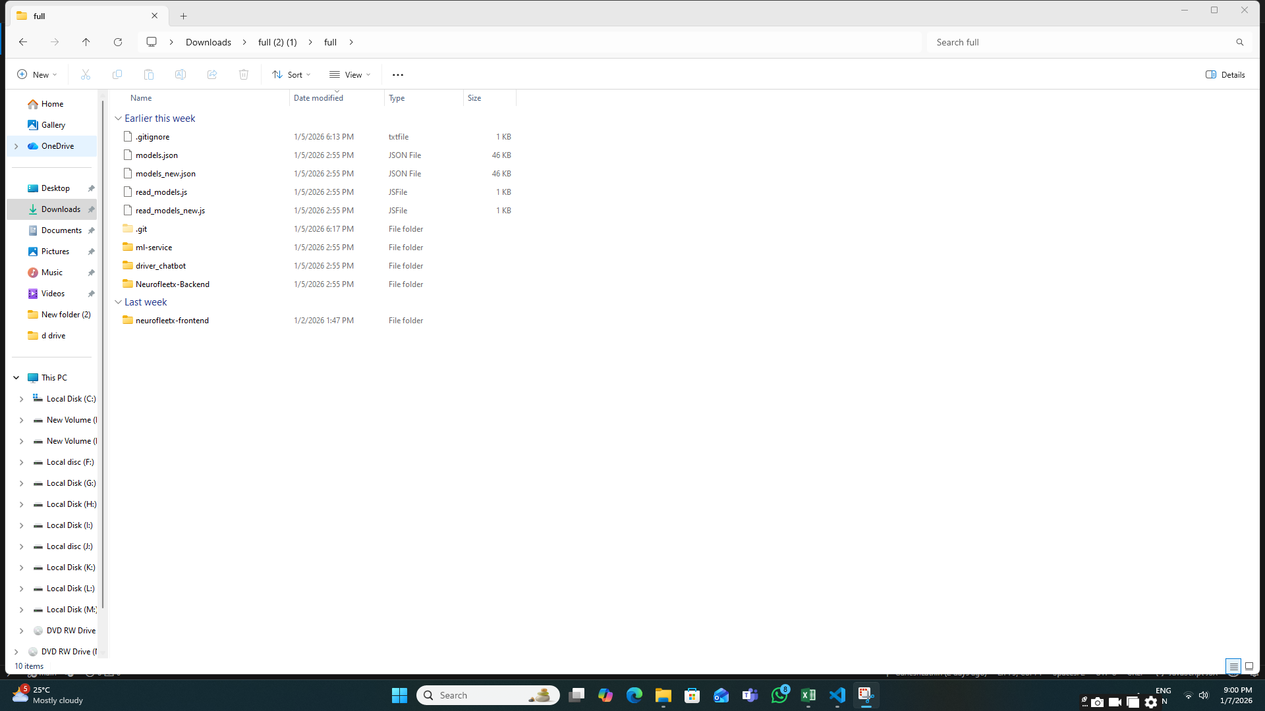

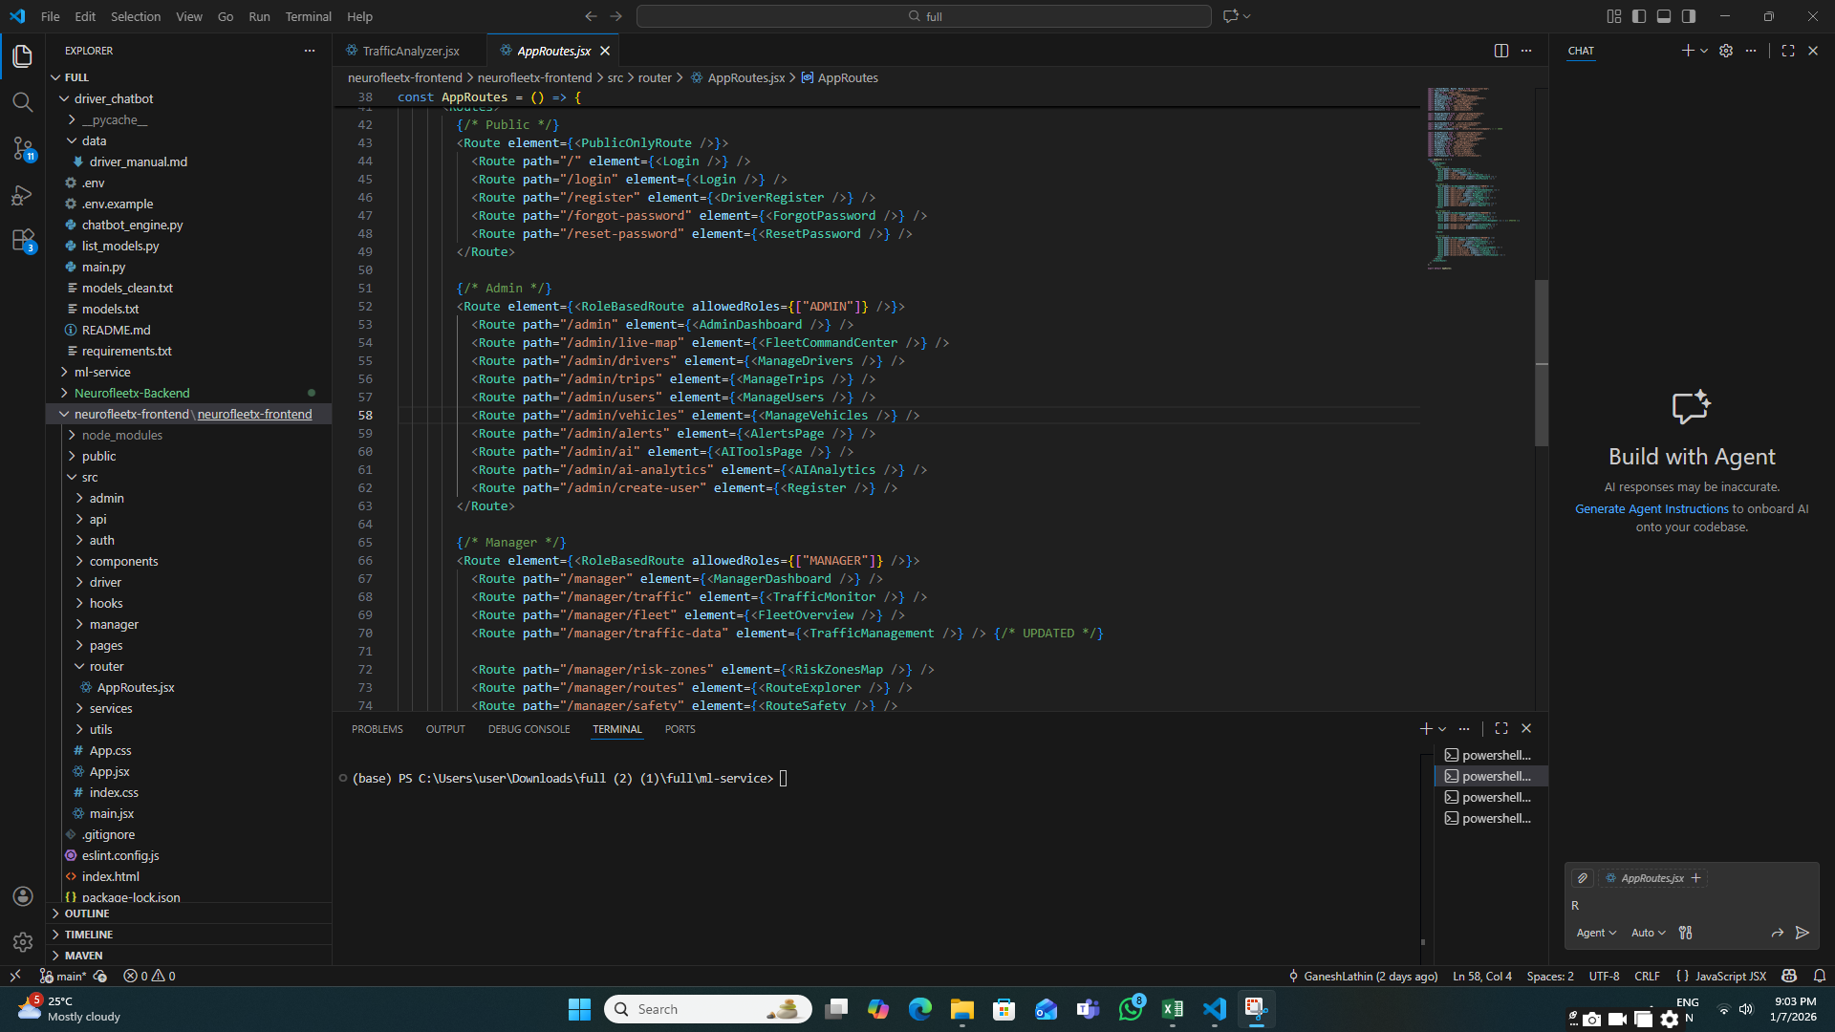

**Step 3 : Login / Signup Navigation**

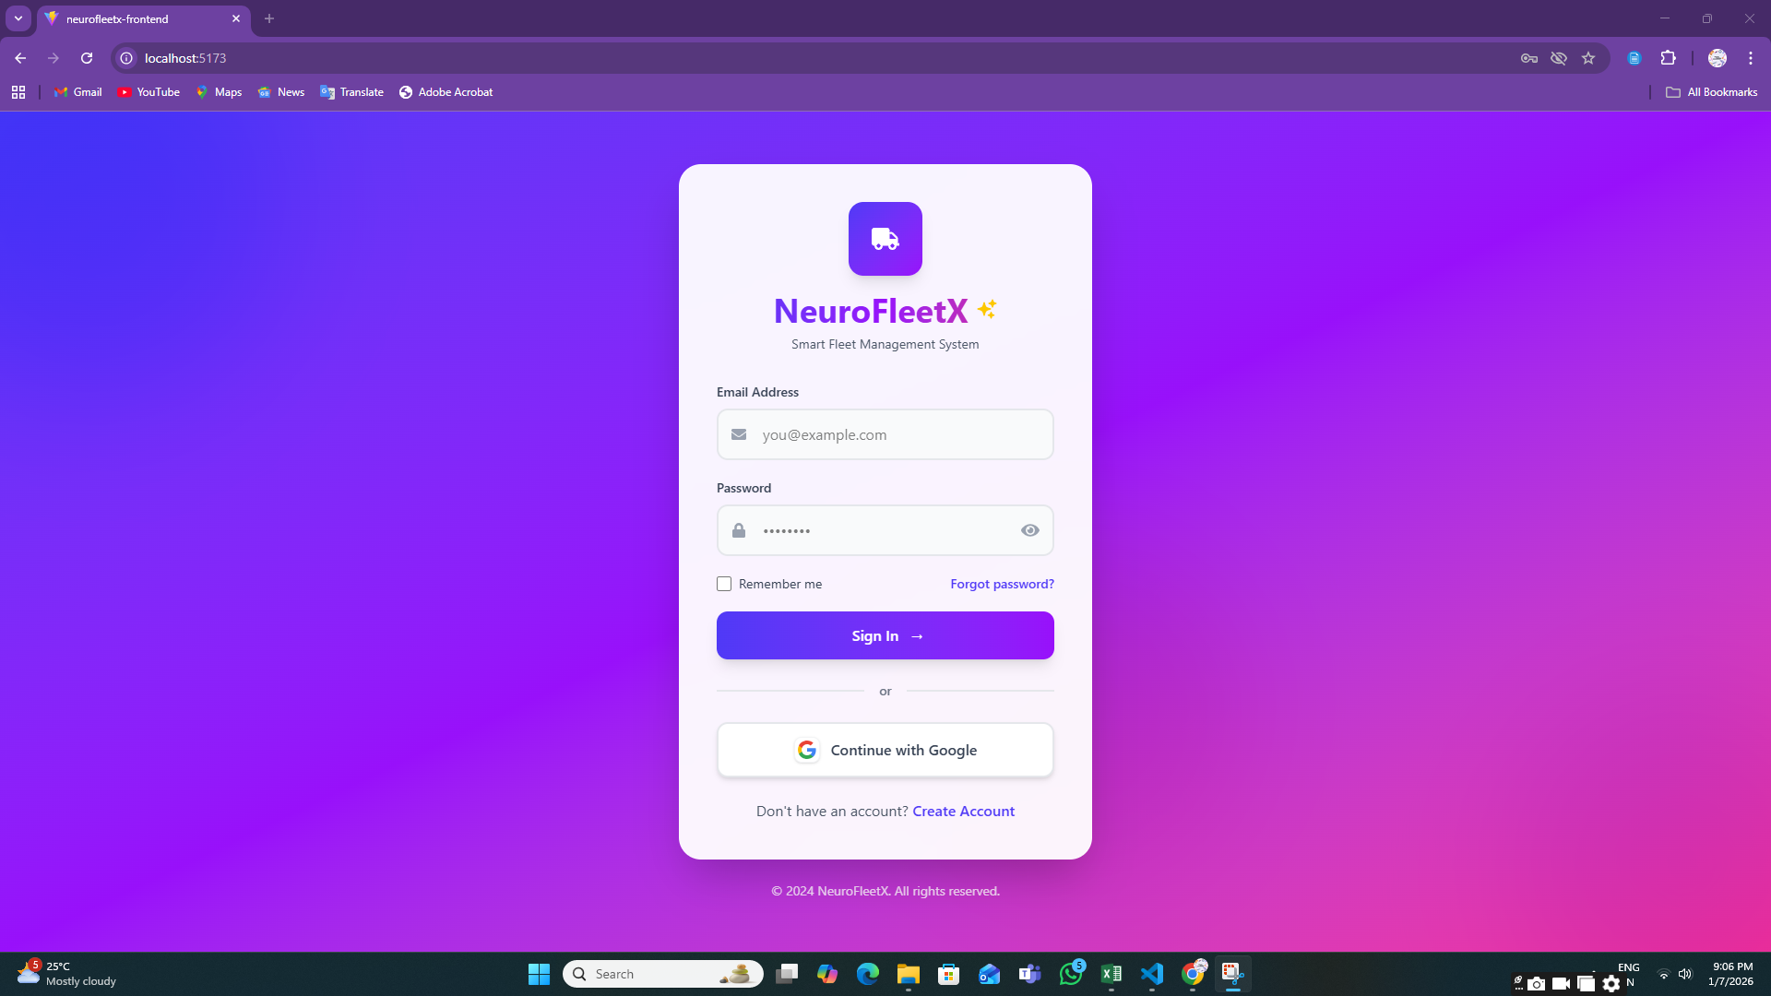 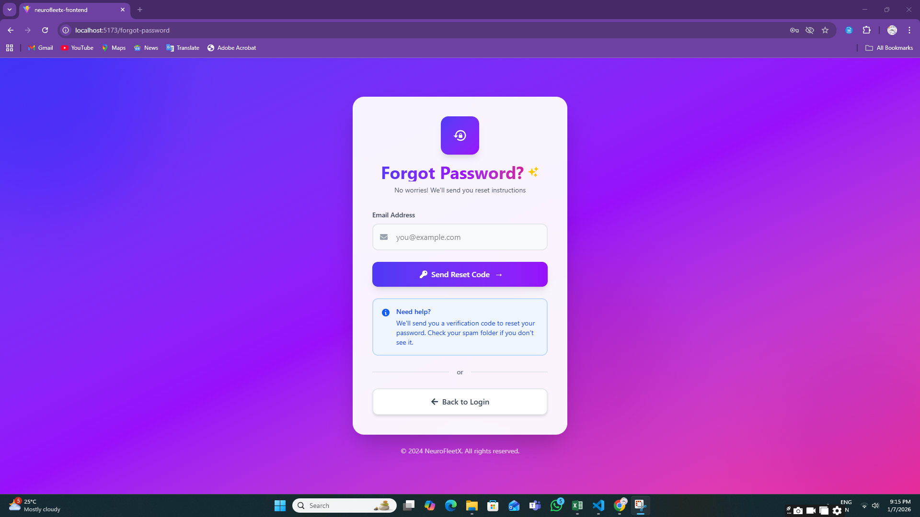

**Step 4: Registration Page**

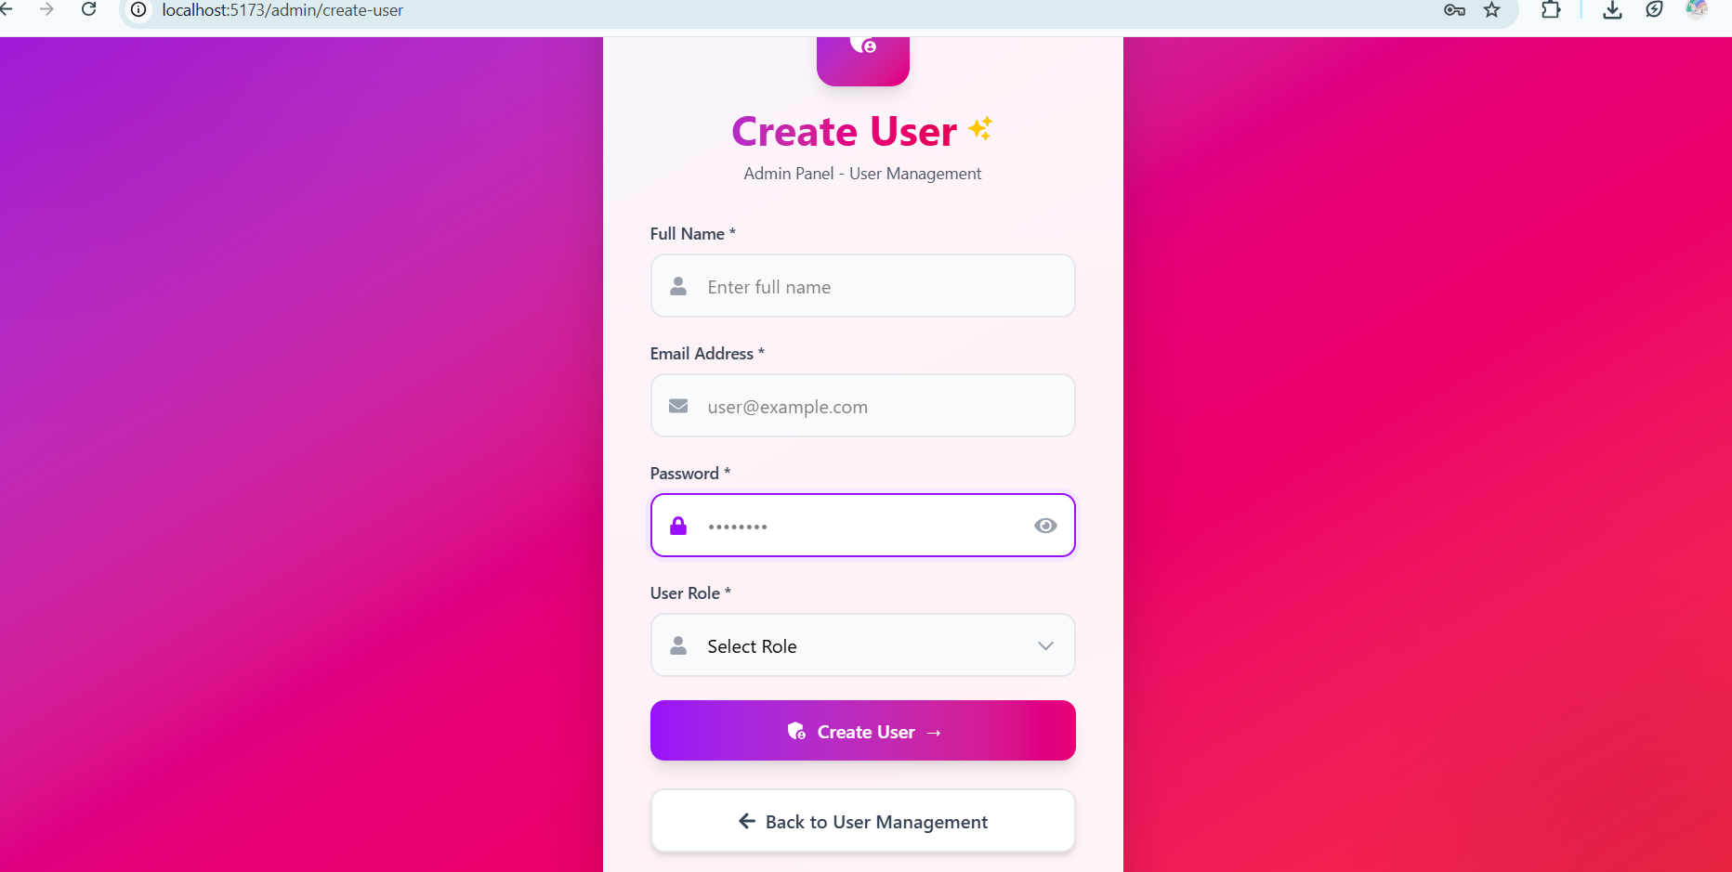

**Step 5: Role-Based Redirection**

After successful login, users are automatically redirected to their respective dashboards:

* **Admin Dashboard**

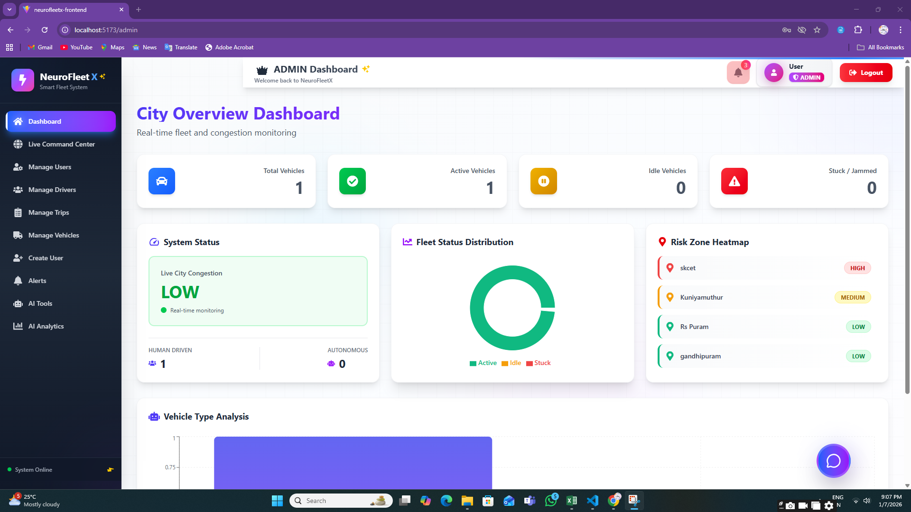

* **Manager Dashboard**

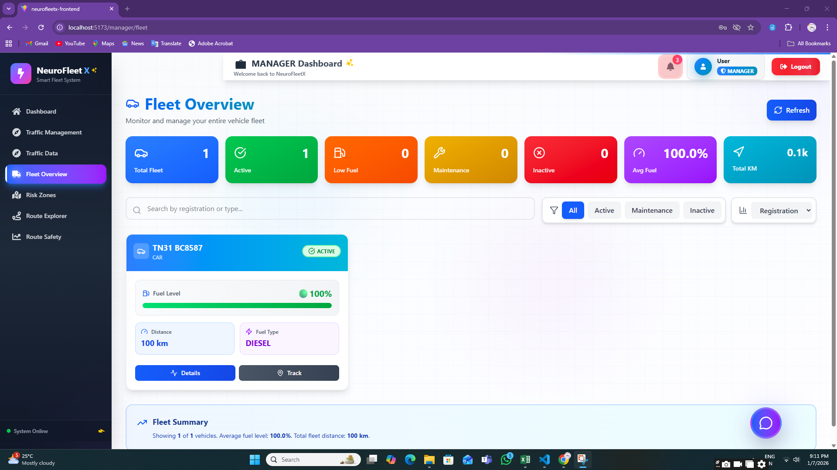

* **Driver Dashboard**

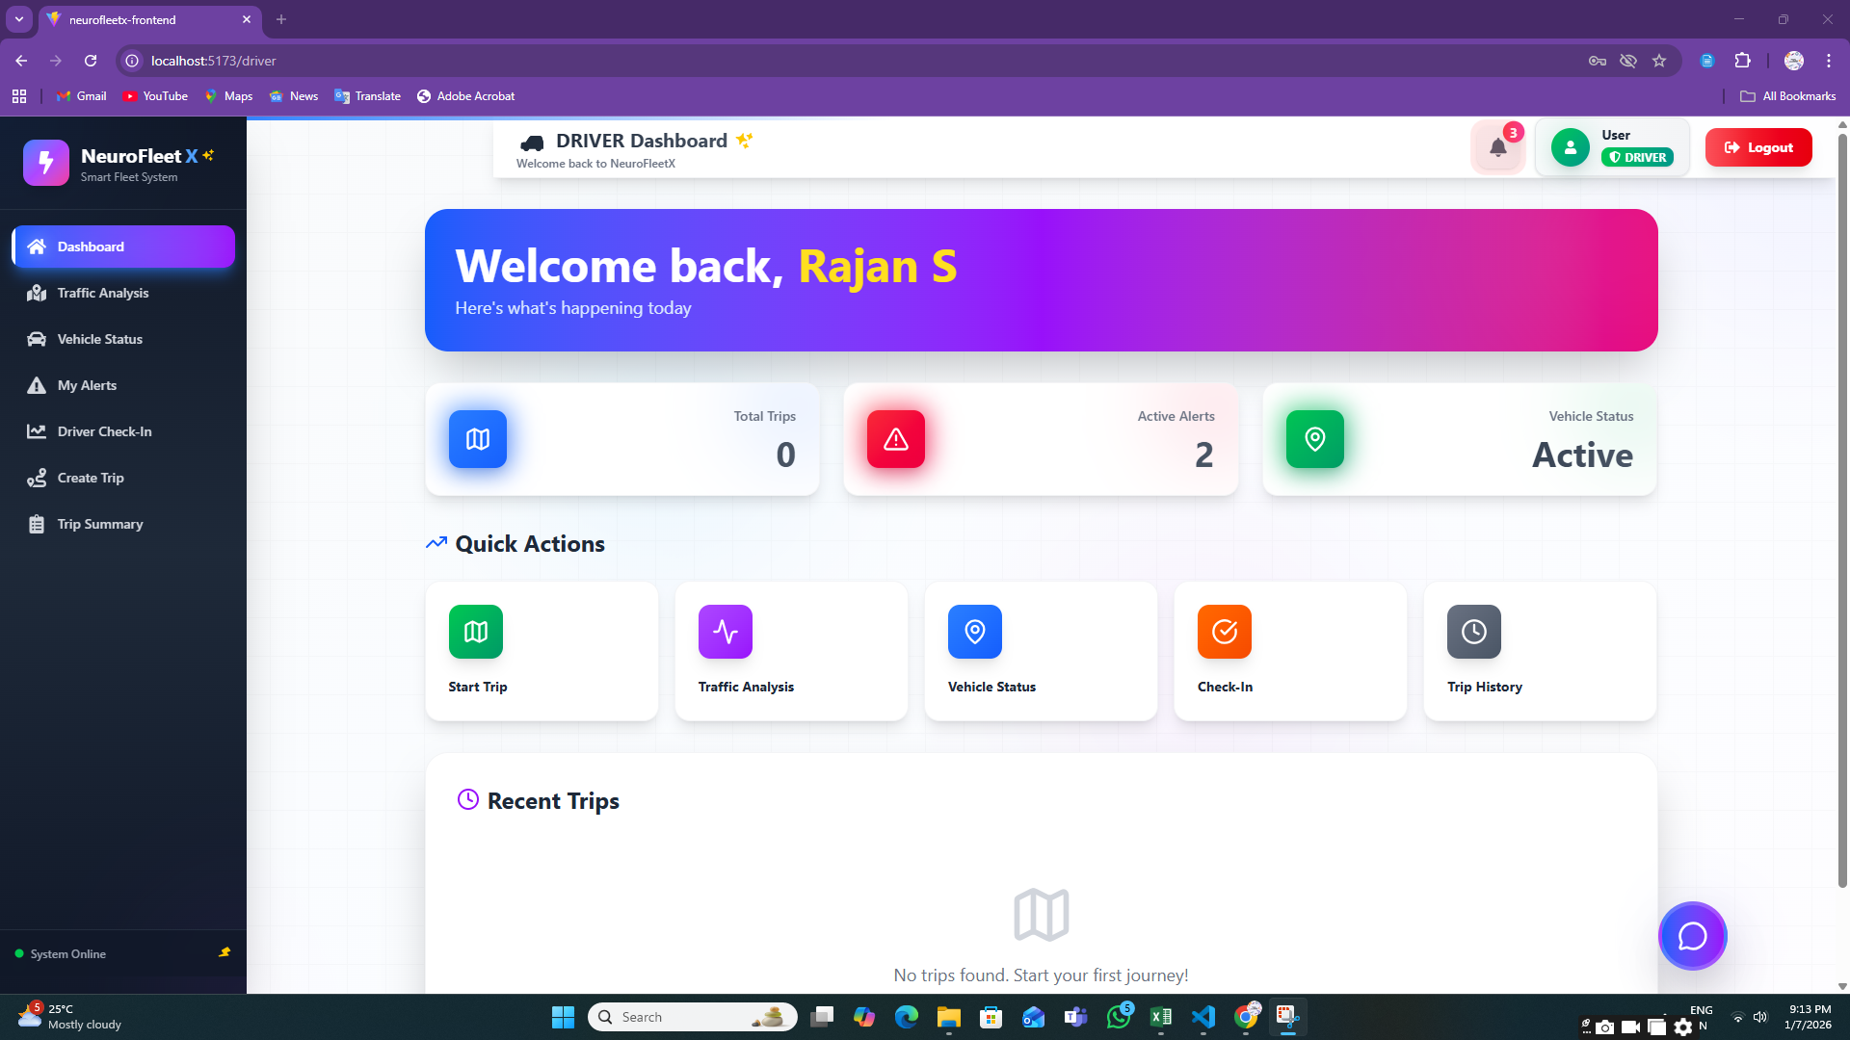

This confirms role-based access control.

**Step 6: ADMIN MODULE**

**6.1:** **Vehicle Management Page**

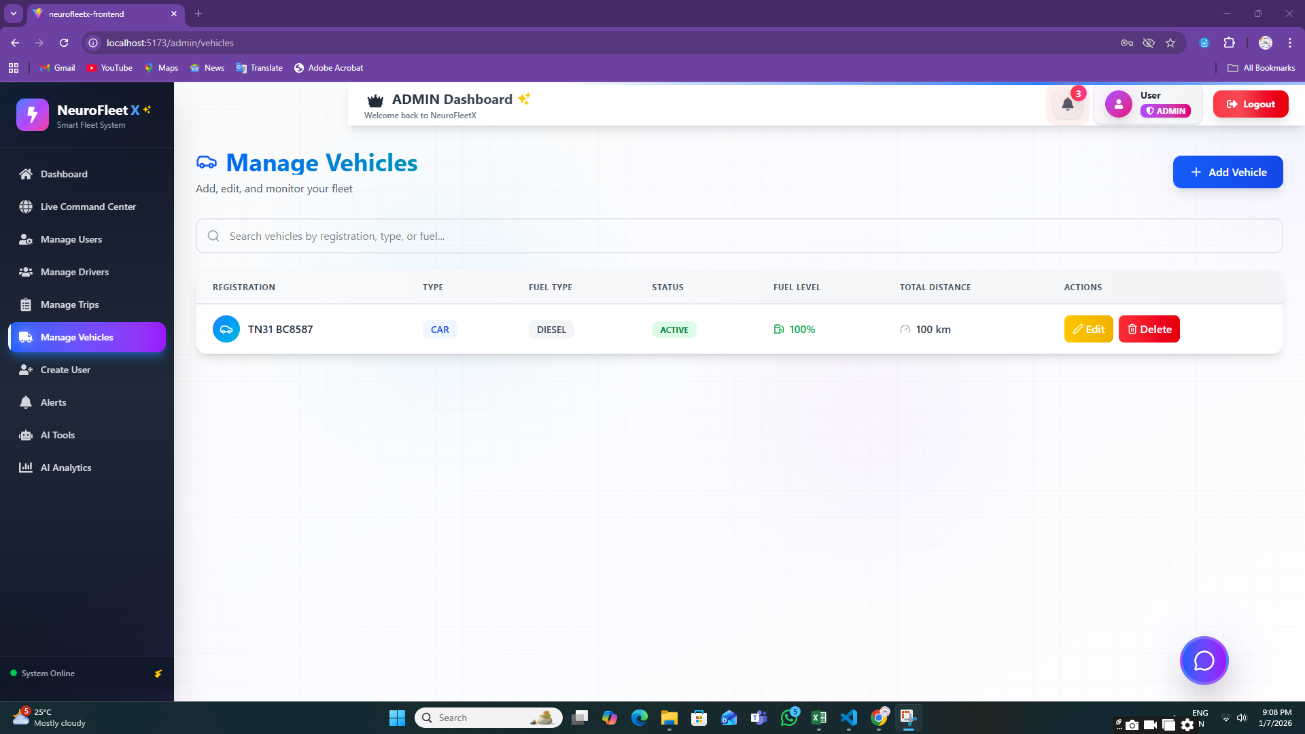

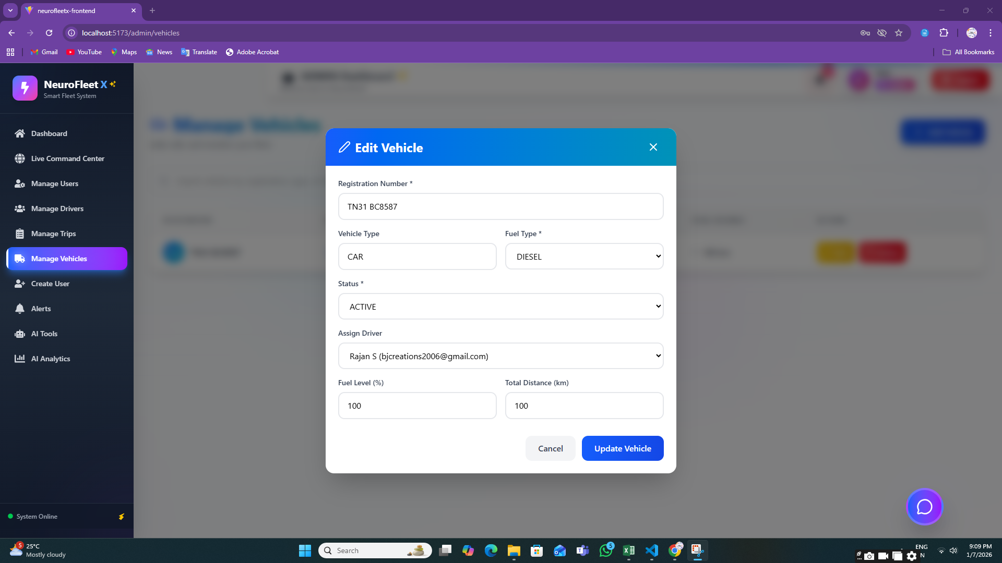

**6.2:** **User Management Page**

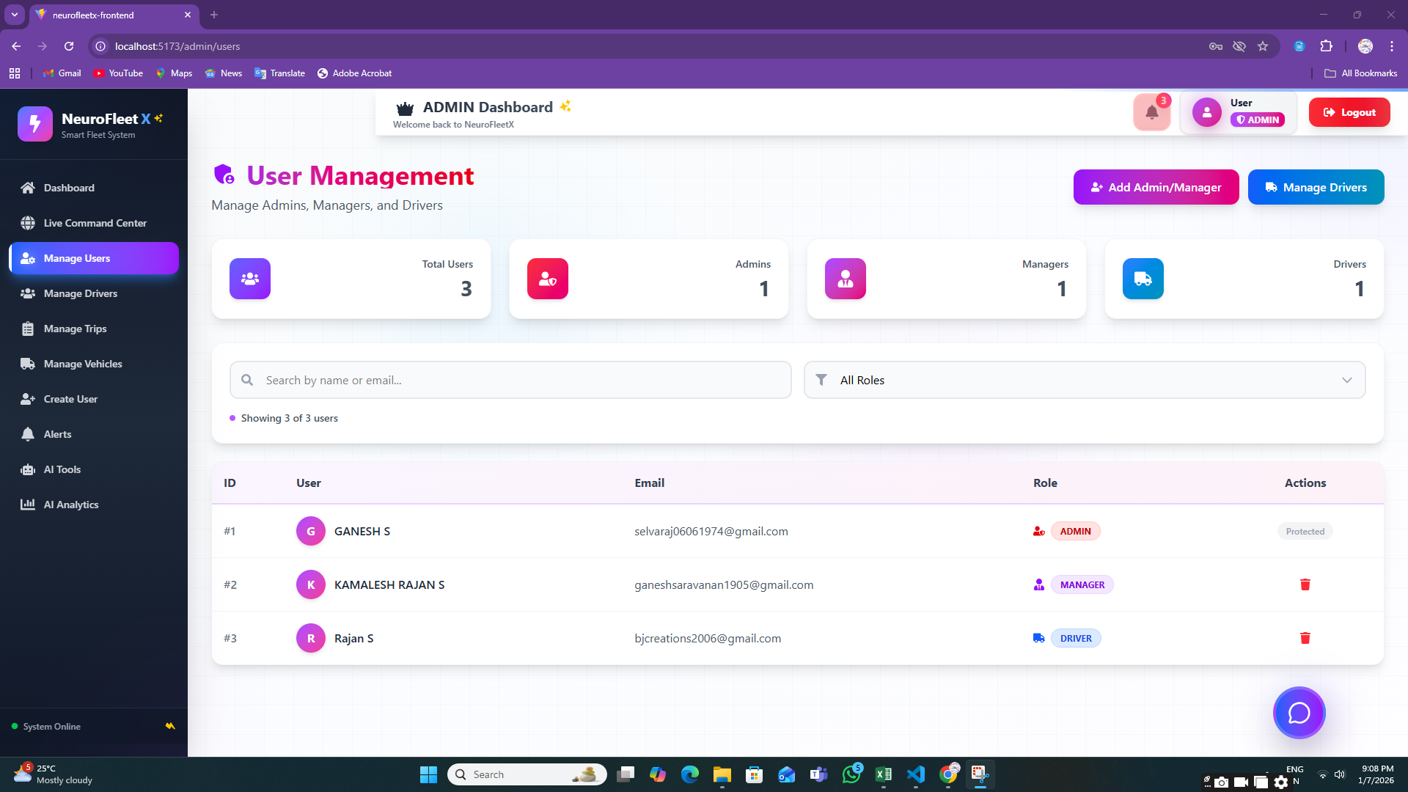

**6.3:** **Driver Management Page**

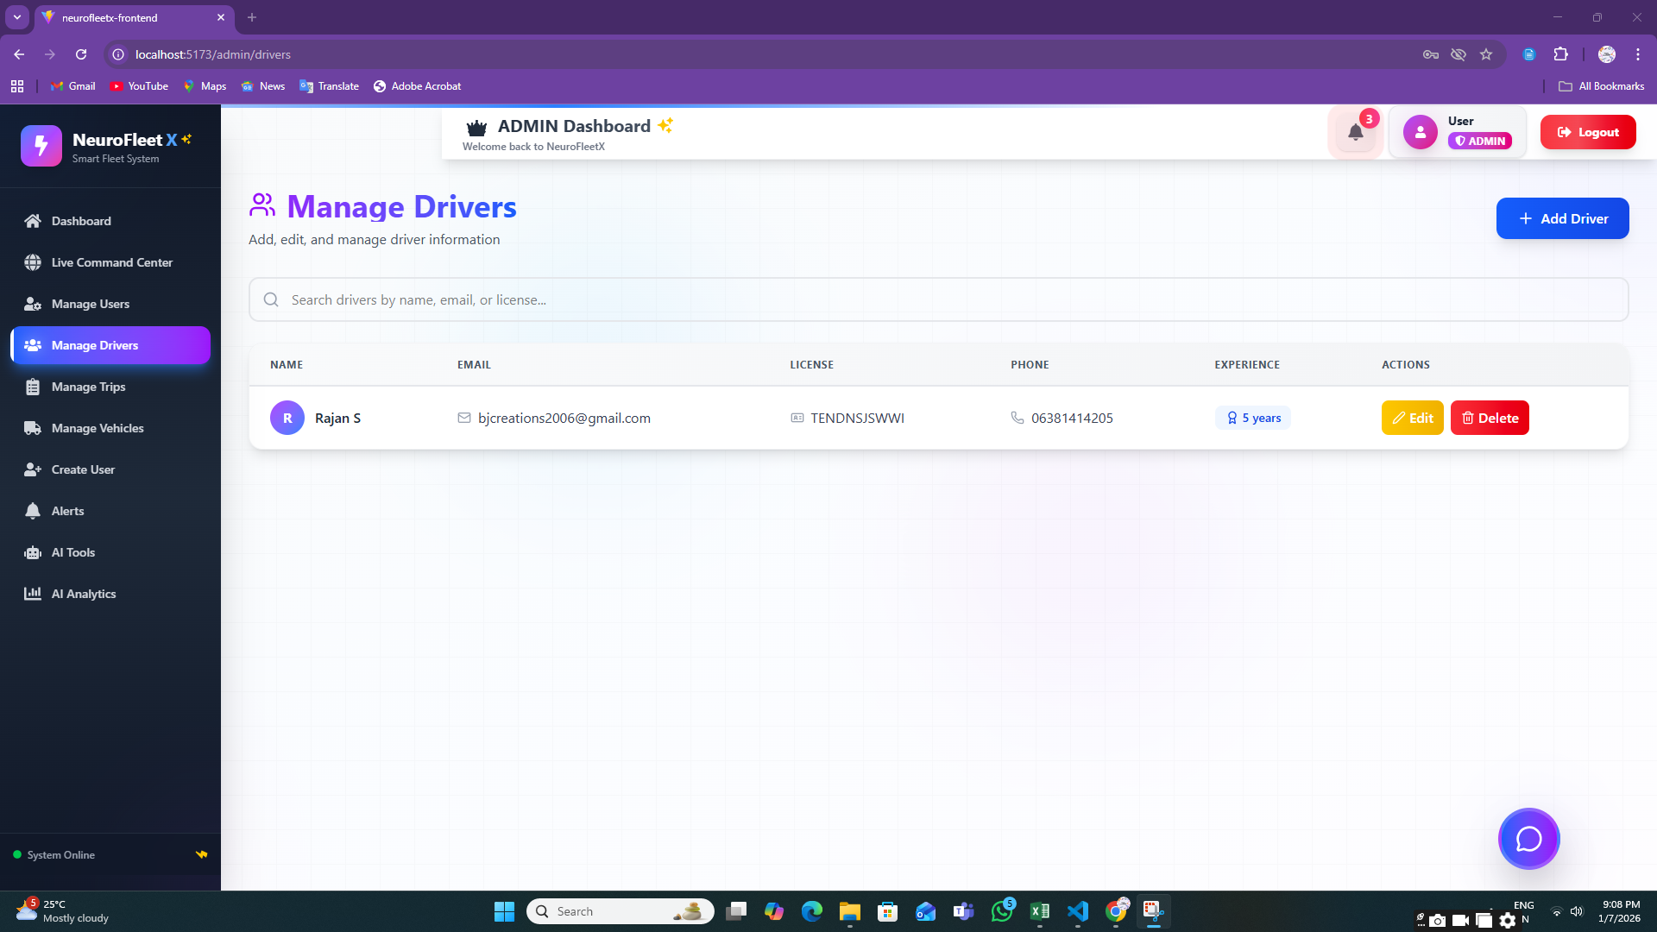

**6.4:** **Alerts Page (Admin View)**

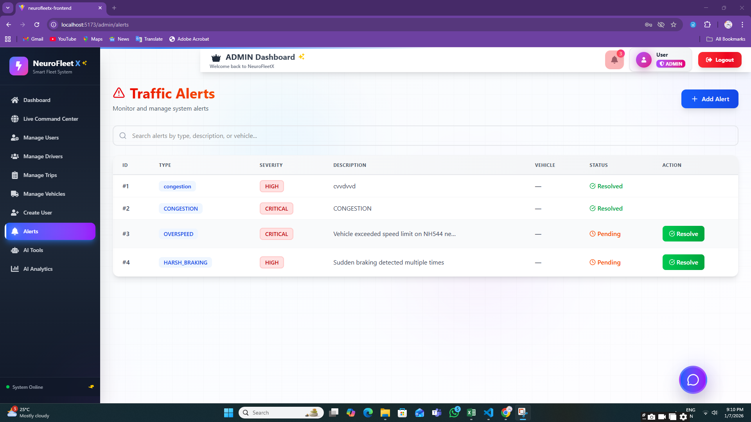

**6.5:** **AI Analytics Page**

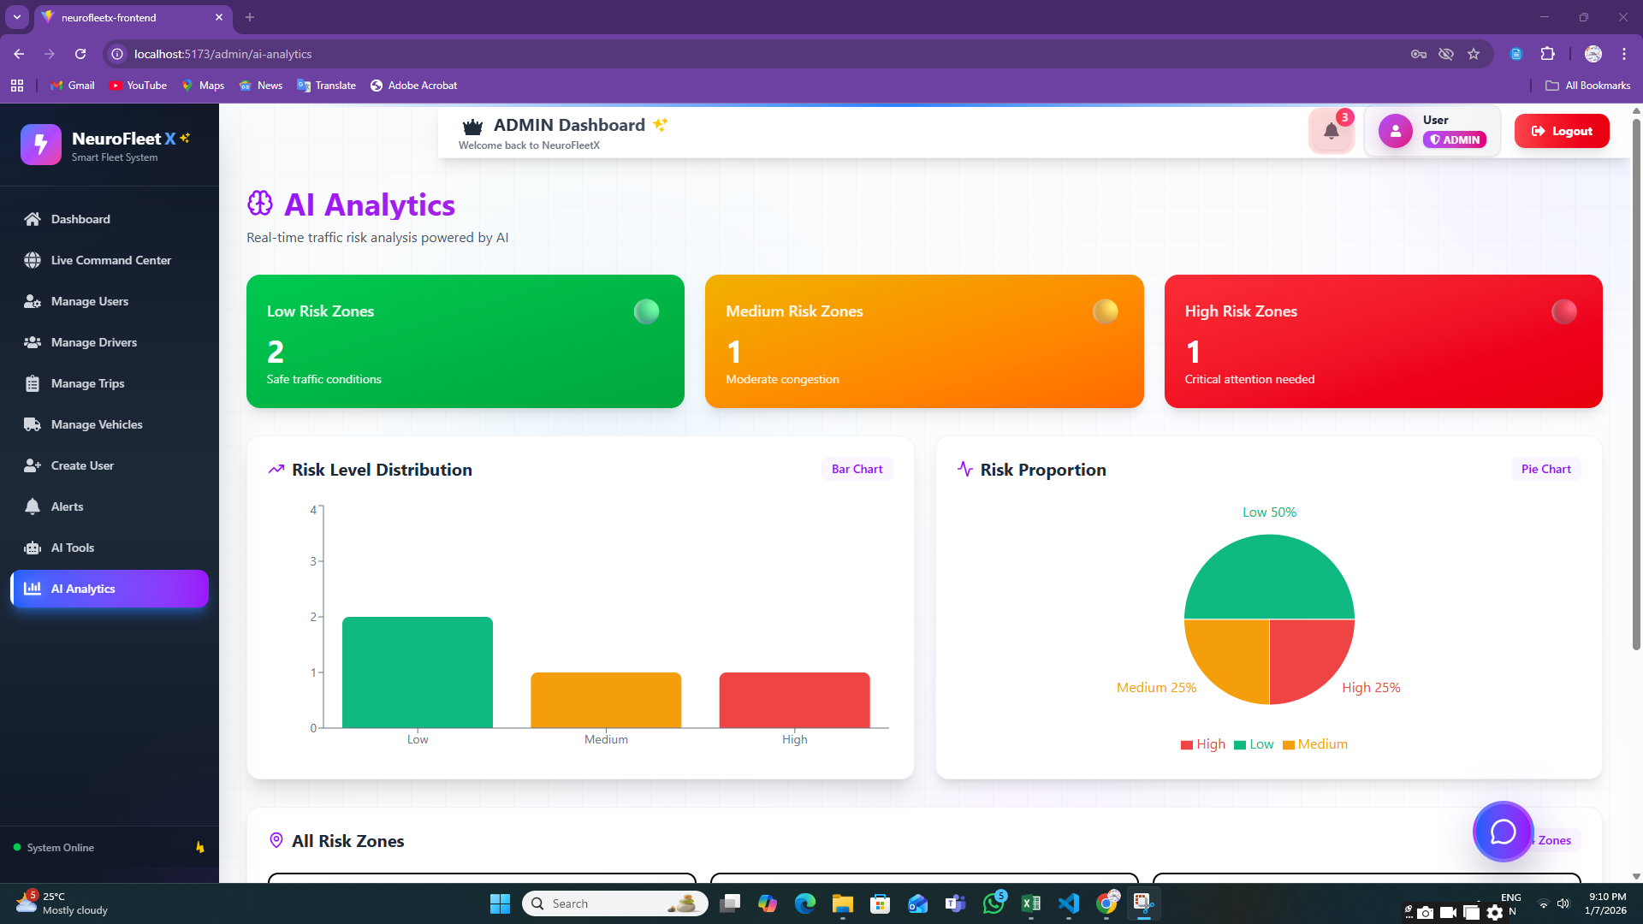

**6.6:AI Tools**

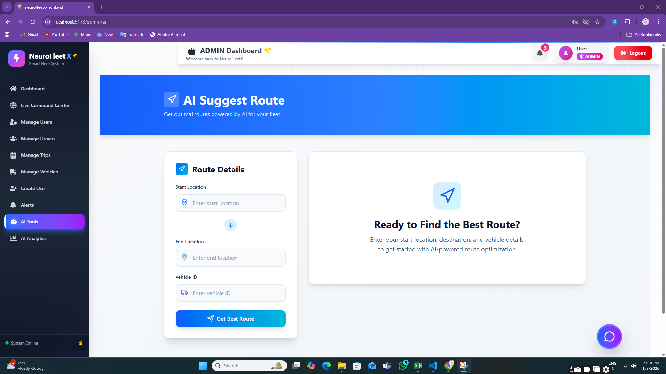

**6.7:Manage Trips**

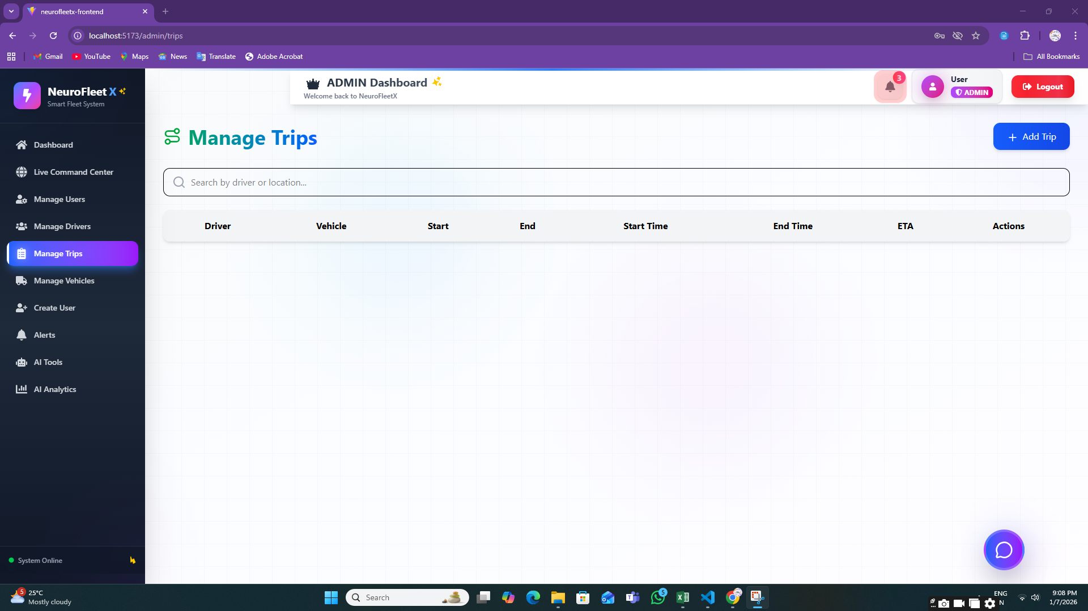

**Step 7:** **MANAGER MODULE**

**7.1:Traffic Management Page**

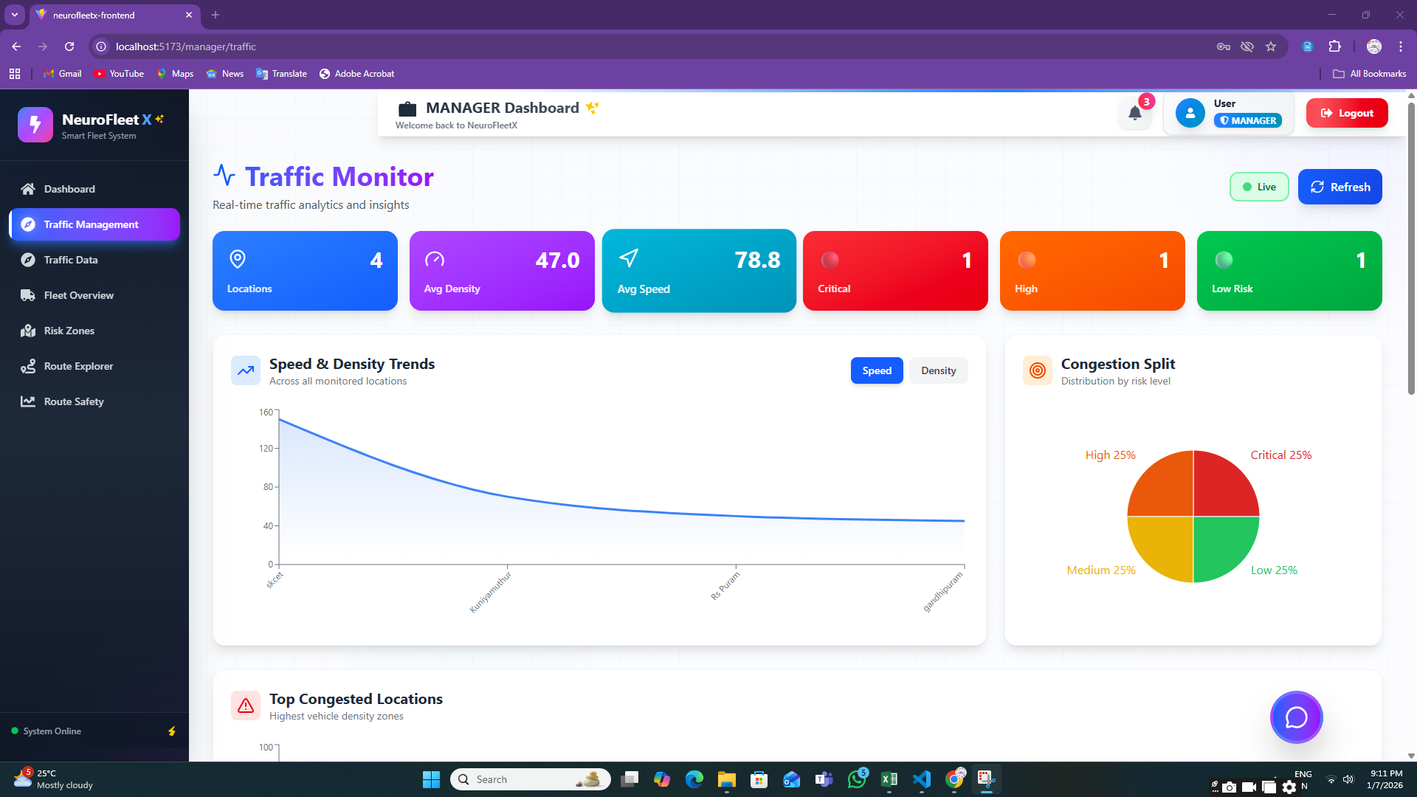

**7.2:** **Risk Zone Map**

**7.3:Traffic Data**

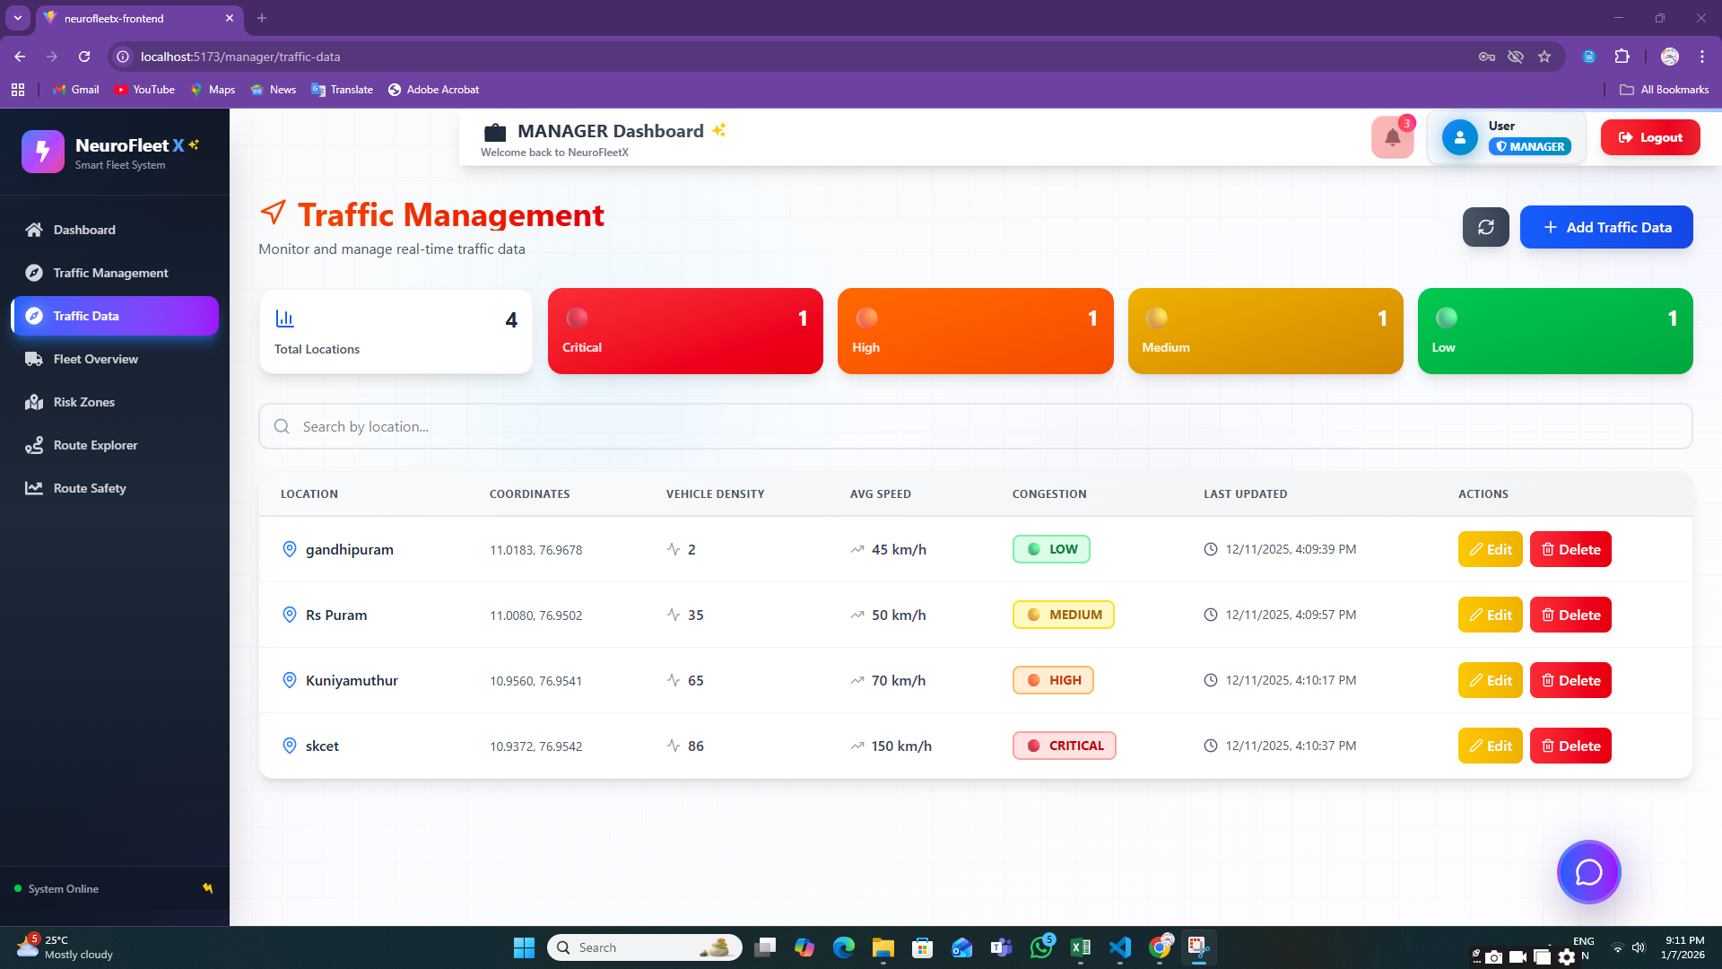

**7.4:Route Explorer**

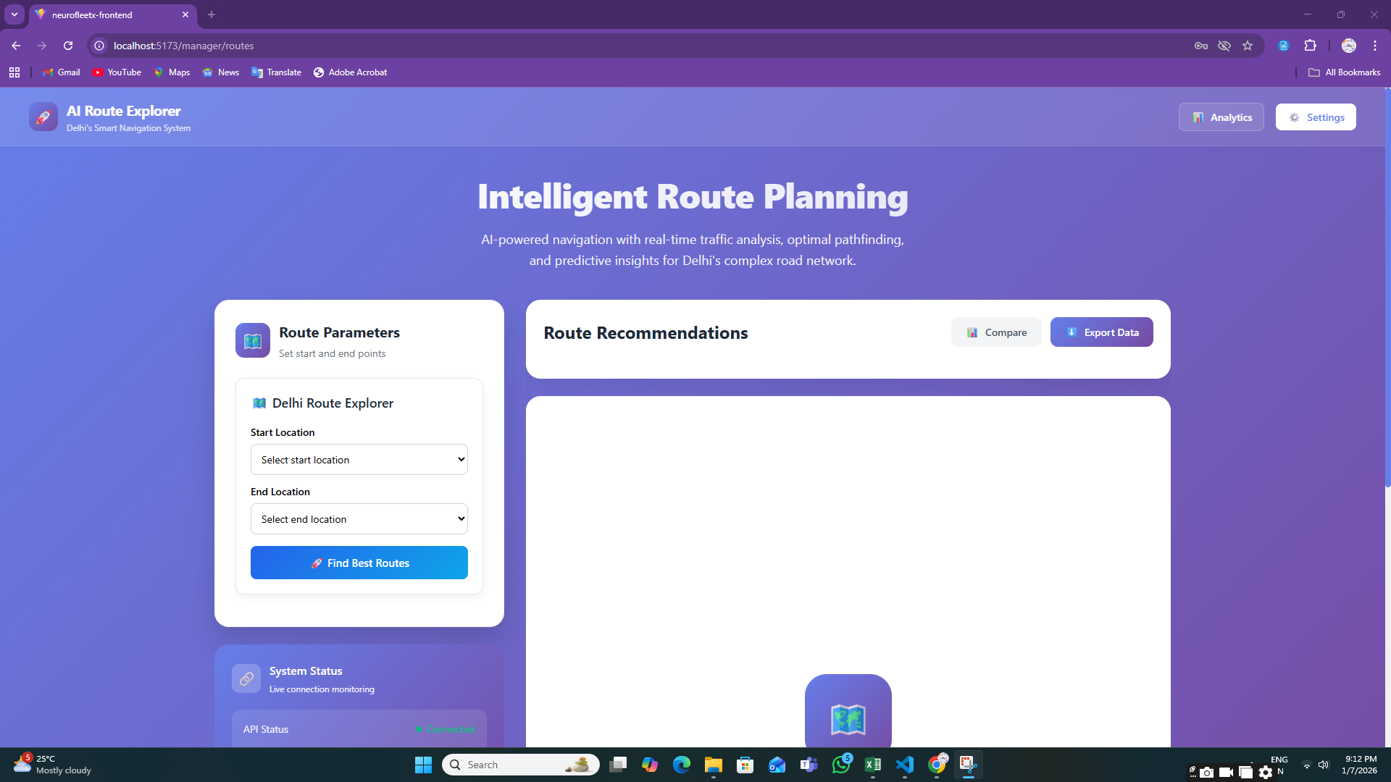

**7.5:Route Safety Analysis**

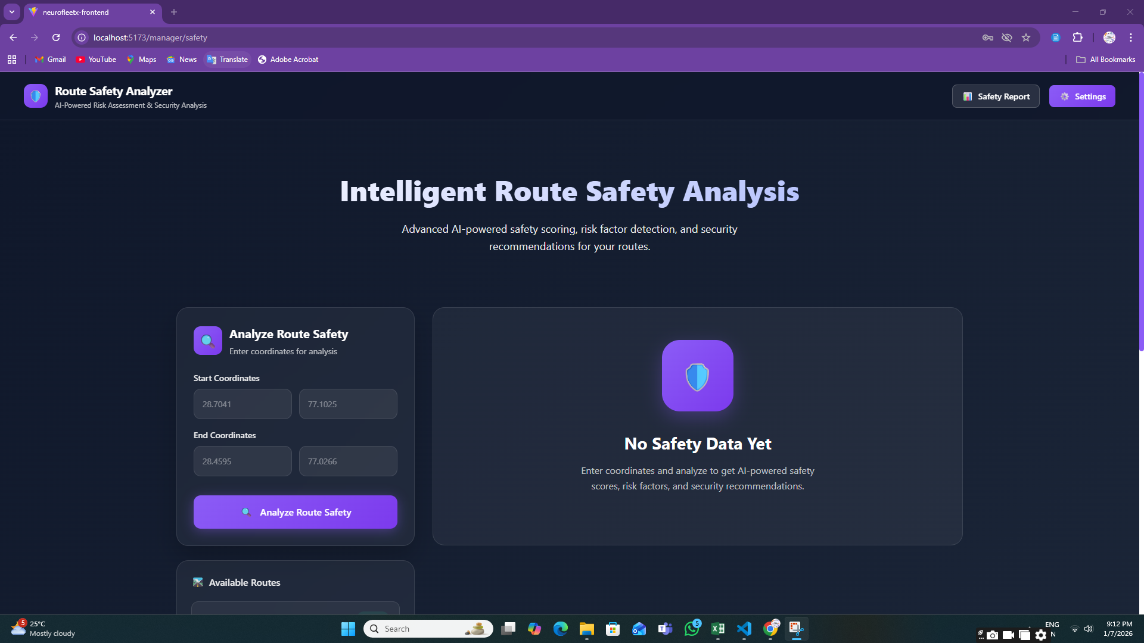

**Step 8:** **DRIVER MODULE**

**8.1:** **Create Trip Page**

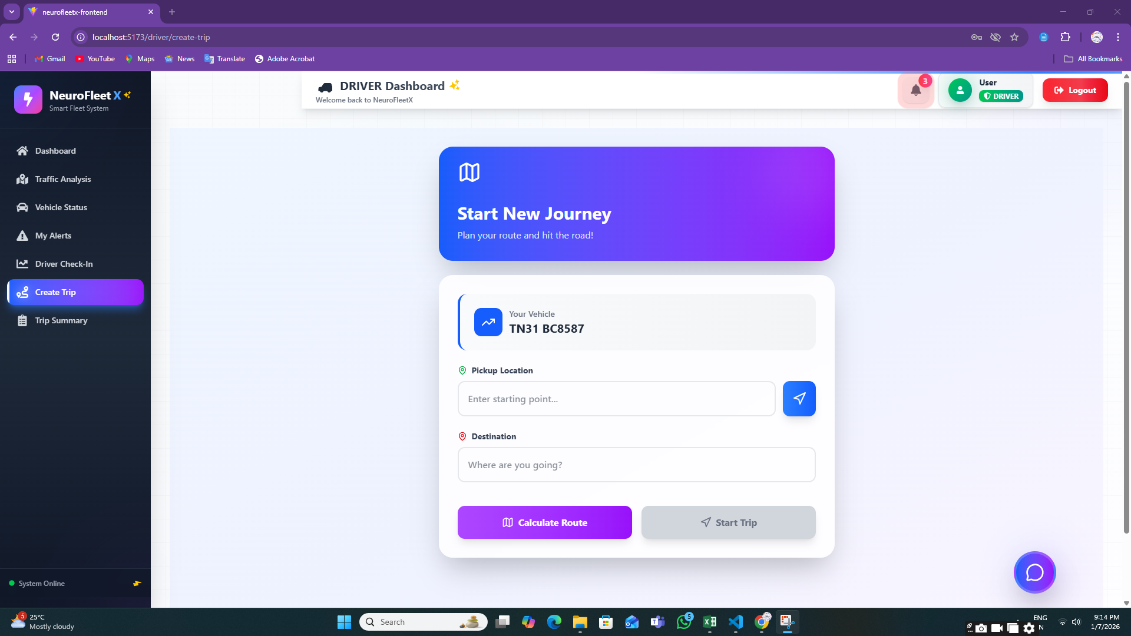

**8.2:** **Route Explorer**

**8.3:** **Traffic Analysis Page**

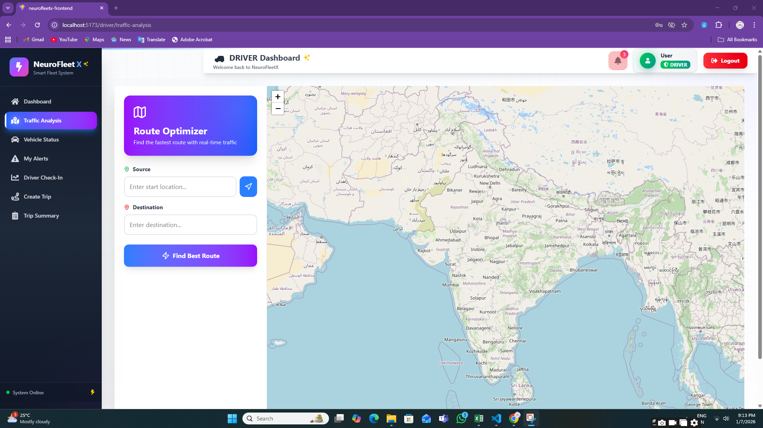

**8.4:** **Vehicle Status Page**

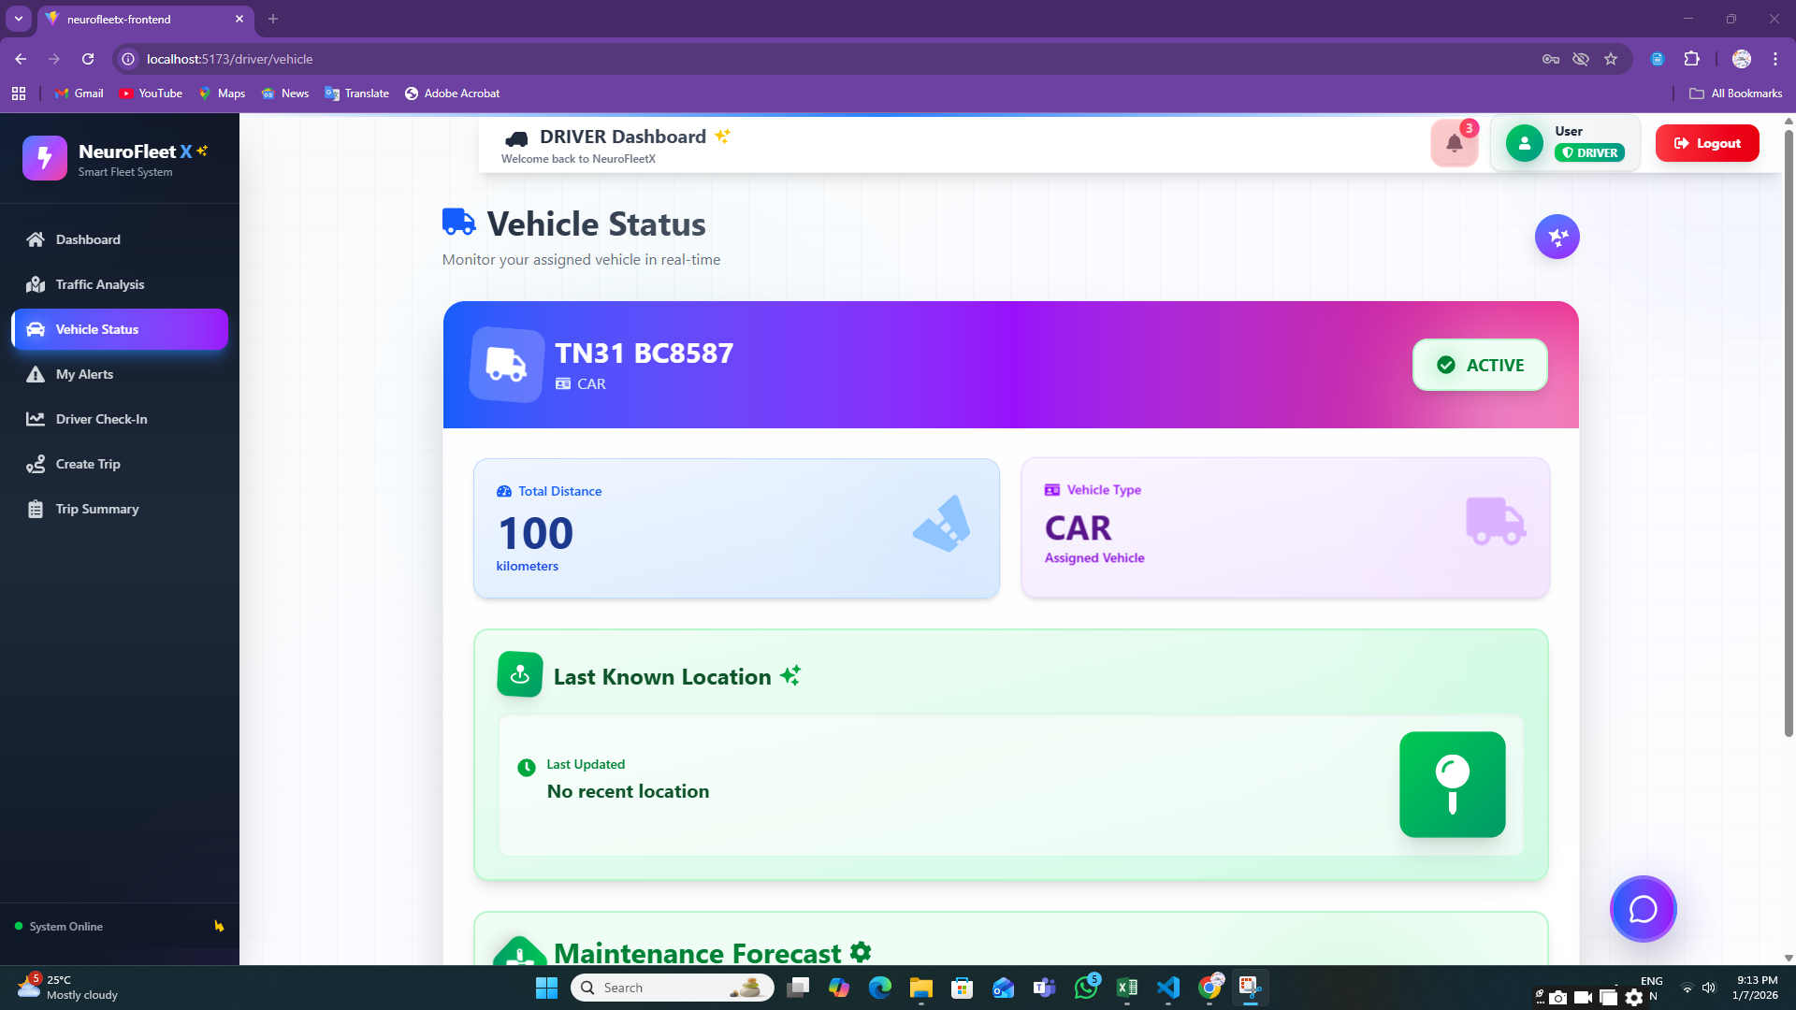

**8.5:** **My Alerts Page**

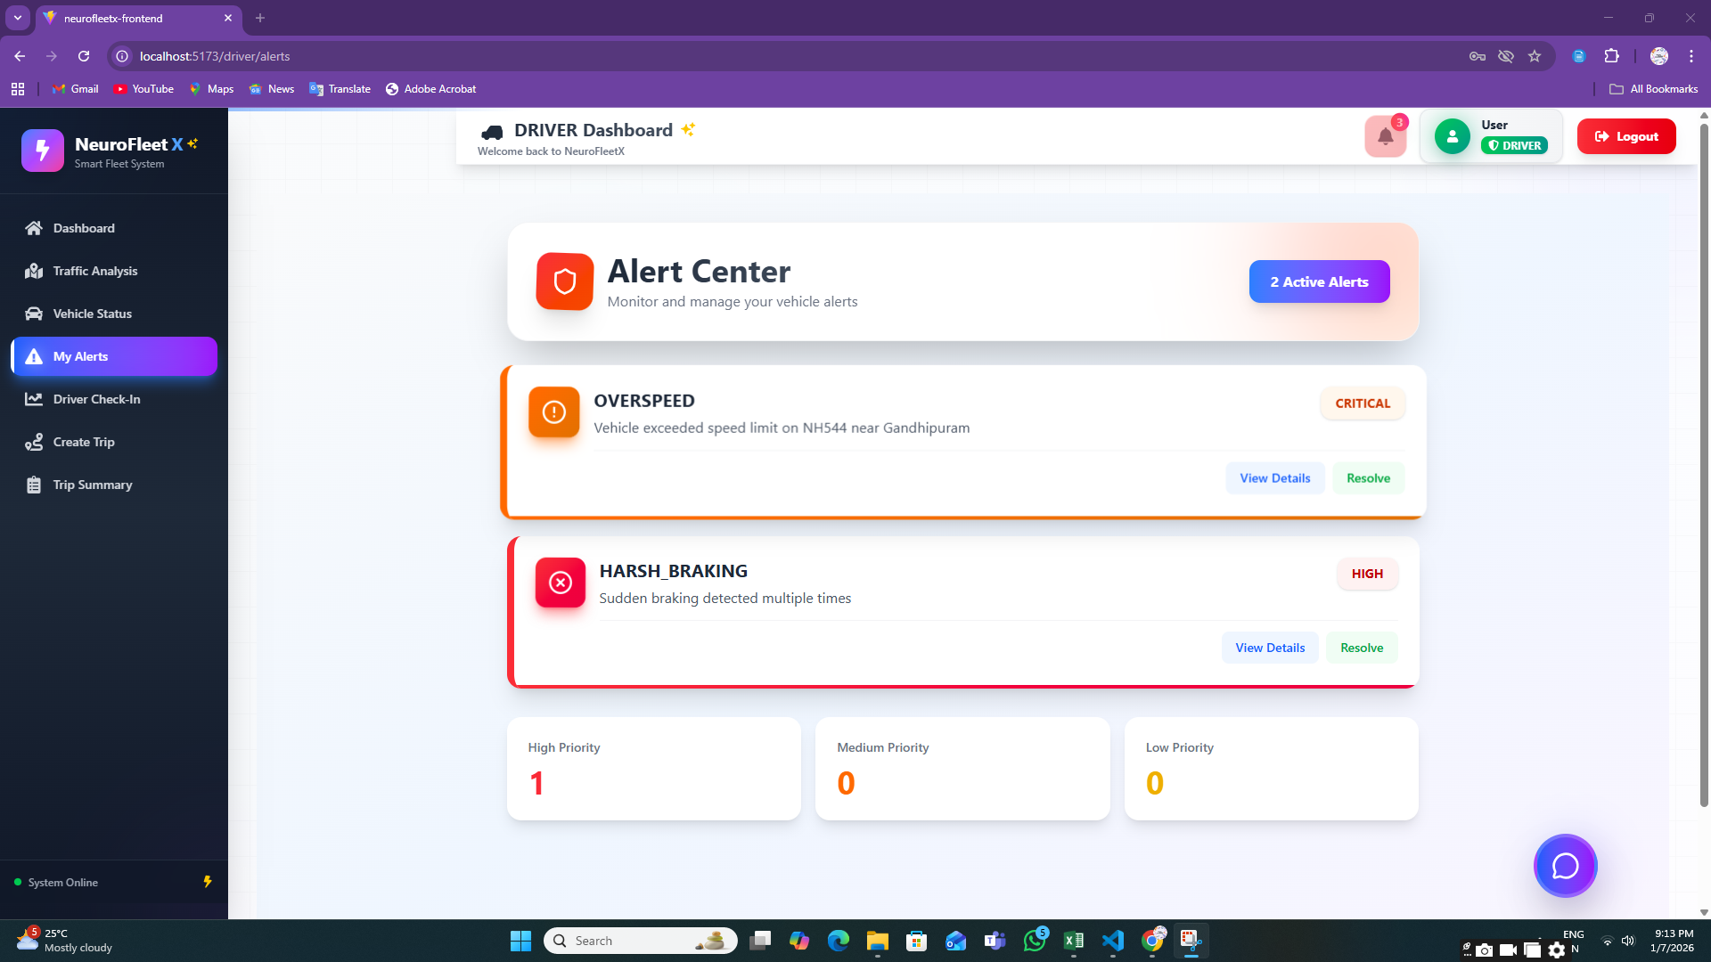

**8.6:** **Driver Check-In**

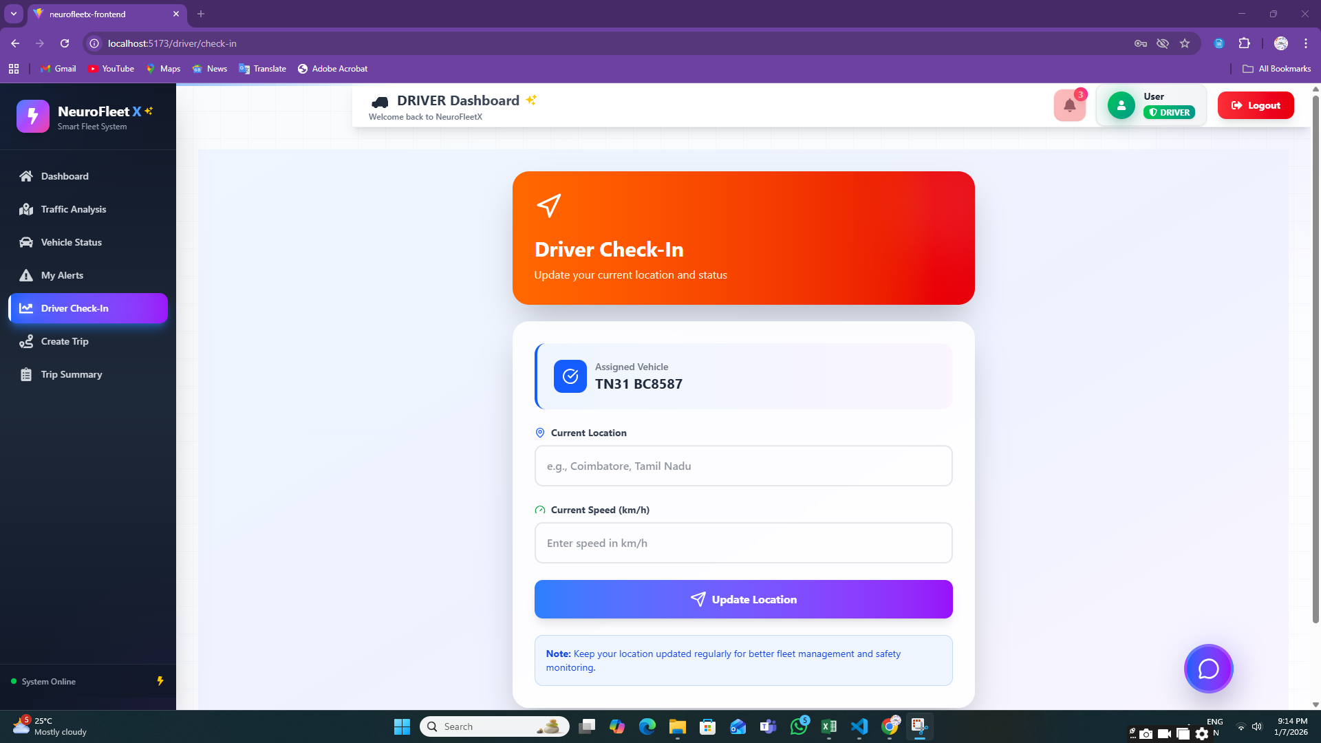

**8.7:** **Trip Summary Page**

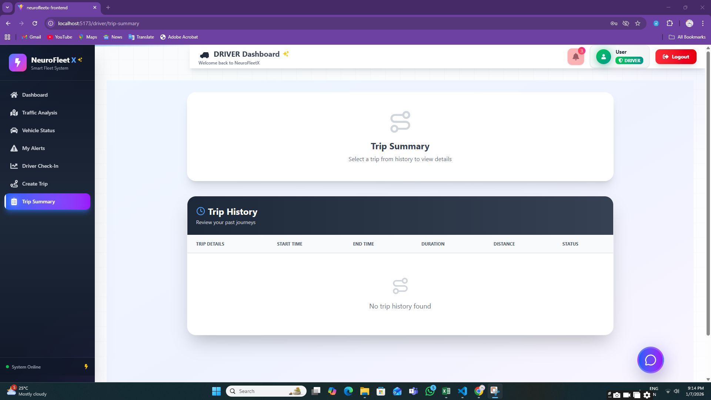

**7. Challenges Faced**

* Limited Real-Time Traffic Data  
  Live traffic data was not available, so manually entered and sample data were used.
* AI & ML Understanding  
  Learning AI concepts and applying them to traffic prediction and risk analysis was challenging at the beginner level.
* System Performance Limitations  
  Laptop performance and memory constraints affected AI experimentation and backend processing.
* AI Integration Complexity  
  Integrating AI-assisted logic with backend services and frontend dashboards required repeated testing and debugging.
* Map & Location Handling  
  Working with maps, coordinates, and location-based data required careful implementation.

# Role-Based Access Control Managing permissions for different user roles using JWT needed additional attention to security logic.

# Time Management Balancing learning, development, testing, documentation, and presentation within the given timeline was difficult.

# 8. Learnings & Skills Acquired

* AI Concepts (Basic Level)  
  Gained basic understanding of how AI supports traffic analysis, congestion detection, and route suggestions.
* Full-Stack Development  
  Developed practical skills in React, Spring Boot, and MySQL.
* JWT Authentication  
  Learned to implement token-based authentication and role-based authorization.
* Dashboard & Visualization Skills  
  Designed dashboards using charts, maps, and color indicators.
* API Development & Integration  
  Improved skills in REST API creation and frontend-backend integration.
* Problem Solving & Debugging  
  Learned to identify issues, debug errors, and enhance system stability.
* Team Collaboration  
  Improved communication and teamwork while working on shared project modules.

**9. Testimonials from team**

Team Member 1:  
“This project helped me understand how AI concepts can be applied to real-world traffic problems and improved my backend development skills.”

Team Member 2:  
“I learned how to design dashboards and visualize traffic data in a simple and user-friendly way.”

Team Member 3:  
“Working on NeuroFleetX improved my understanding of authentication, role-based access, and system integration.”

Team Member 4:  
“This project gave me confidence to work on full-stack applications and understand how smart city solutions are built.”

**10. Conclusion**

# The NeuroFleetX project successfully showcases a role-based fleet and traffic management system. It offers clear dashboards, alerts, traffic analytics, and AI-assisted features to improve safety and traffic awareness. Although advanced AI models are not fully implemented, the system is designed to support future AI and ML integration. Overall, the project provided valuable technical experience and a strong understanding of intelligent transportation systems.

# 11. Acknowledgements

I sincerely thank our institution and organization for providing the opportunity to work on the NeuroFleetX project. I am grateful to our mentor for continuous guidance, encouragement, and valuable feedback throughout the project. I also thank my team members for their cooperation and support, which played an important role in the successful completion of this project. Finally, I appreciate everyone who directly or indirectly contributed to our learning and project success.